Notes: Lesson 1.3.2 Creating and Graphing Exponential Equations
Reviewing exponential equations:
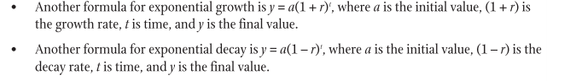
Compound Interest Formula:
- The general form of the compound interest formula is ________________,
where A is the _________ ________, where r is the ___________, ________, n is the number of ________the investment is compounded in a
year, t is the number of __________ the investment is left in the account to
grow.

- Use this chart to reference:

Compounded… | n (number times per year)
Yearly/annually
Semi-annually
Quarterly
Monthly
Weekly
Daily

- When graphing exponential equations, you have to use a table of values.

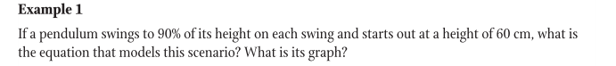
Initial height = _______ a = ______
Decay rate = _______ b = ______
x | y
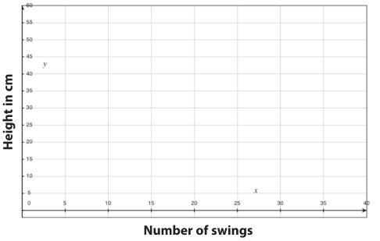
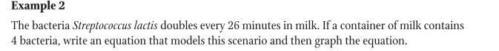
Initial bacteria count =______ a = _____ 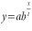
Base = _____ b = _____
Time period = ______ x = _____

x | y
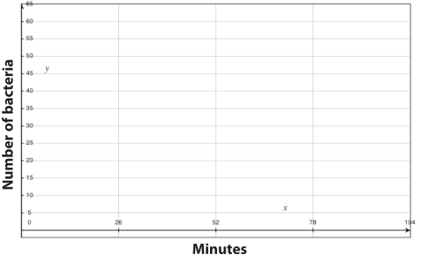
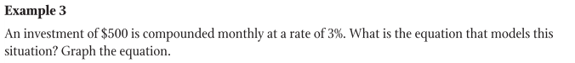
Initial investment = ______ P = _______ 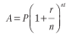
r = _____ r = _______
Compounded monthly = _______ n = _______
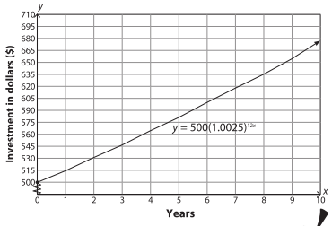

Example 4
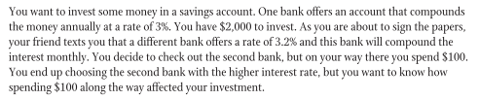
a) What is the equation for the investment at the first bank?

b) What is the equation for the investment at the second bank? Keep in mind that you
spent $100 of the money you initially planned to invest.

c) Using the graphing calculator, graph the equations on the same coordinate plane.
To do this, first rewrite each equation in the form of y = abᵡ.
A = 2000(1.03)ᵗ becomes ____________________
A = 1900(1.00267)¹²ᵗ becomes __________________.
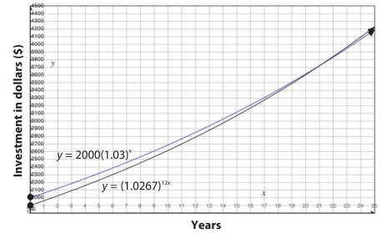
d) Looking at the graph of the investment you actually made, how many years does it take
to earn back the $100 you spent?

e) How many years does it take before the investment will be equal to the investment you
almost made?

