Inequalities Name_________________
1. Write the inequality for each situation. Choose “x” as your variable.
a) The sum of a number and twelve is at least ten ____________
b) Twice a number decreased by nine is at most two _____________
c) One-third of a number is no less than thirty ______________
2. Write the inequality for each graph. Choose “x” as your variable.
a) 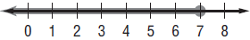_________
b) 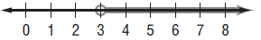_________

Solve each inequality. Graph the solution on the number line.

<+++++++++++++++> <++++++++++++++> <++++++++++++>

<+++++++++++++++> <++++++++++++++> <++++++++++++>

