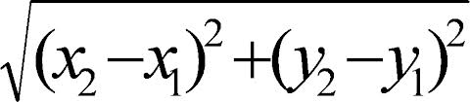
Distance formula steps
- Find the coordinates
- Label my coordinates
- Write down my distance formula
- Plug in the coordinates into the distance formula
- Keep, change, flip
- Solve
Remember!
- Square root
- Exponents
- Keep change flip

