Quadratic Inequalities

A ball thrown is modeled by the function: 3 + 22x – 16x². Using what you know about quadratic functions, answer the following questions.

Explain what each piece of the function shown above tells you about the height of the ball after it is thrown.
3:

22:

-16:

Sketch the graph, without a calculator, using what you know about quadratic functions.
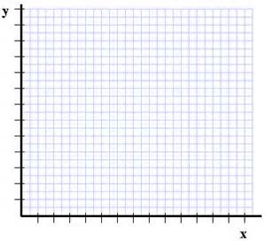

Given the context of the problem, what is an appropriate domain? Why is only the first quadrant of the coordinate plane given for you to graph?

Write an equation to show when the ball will be exactly 10 feet in the air, then solve.

Using this information, write and equation that explains when the ball will be at a height that is less than 10 feet in the air. Then explain the answer based on the previous question’s answers.

Explain how you could use shading to show this solution on the graph?

Write an inequality to show when the ball will be higher than 10 feet in the air.

When will the ball by higher than 10 feet? Write the solution algebraically and graphically.

The student council decides to put on a concert to raise money for an after school program. They have determined that the price of the ticket will affect their profit. The functions shown below represent their potential income and cost of putting on the concert, where t represents ticket price.
Income: I(t) = 330t – 30t² Cost: C(t) = 330 – 30t

Using colored pencils graph each function on the axes below and answer the questions that follow.
- Show algebraically and graphically where the break-even point. (Hint: Income = Cost)

- Show algebraically and graphically where the cost is greater than the income.

- Show algebraically and graphically where the income is greater than the cost.

- Which ticket price would you use in order to maximize your profit? Where is this shown on the graph?

